Session 1 - 1

import java.io.BufferedReader;
import java.io.InputStreamReader;
import java.io.IOException;

public class Solution {
public static void main(String[] args) throws IOException {
BufferedReader br = new BufferedReader(new InputStreamReader(System.in));

// Read number of test cases
int t = Integer.parseInt(br.readLine().trim());

while (t-- > 0) {
String s = br.readLine().trim();
System.out.println(calculateStringSimilarity(s));
}
}

private static long calculateStringSimilarity(String s) {
int n = s.length();
int[] z = new int[n];

// The similarity of the full string with itself is always its length
long totalSimilarity = n;

// Maintain the window [L, R] of the rightmost match
int l = 0, r = 0;

for (int i = 1; i < n; i++) {
if (i <= r) {
z[i] = Math.min(r - i + 1, z[i - l]);
}

// Try to extend the match manually outside the current window
while (i + z[i] < n && s.charAt(z[i]) == s.charAt(i + z[i])) {
z[i]++;
}

// Update the window if the current match extends past R
if (i + z[i] - 1 > r) {
l = i;
r = i + z[i] - 1;
}

// Add the similarity of the current suffix to the total sum
totalSimilarity += z[i];
}

return totalSimilarity;
}
}

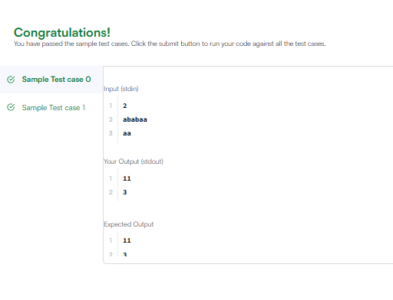

Session 1 - 1

import java.io.BufferedReader;
import java.io.InputStreamReader;
import java.io.IOException;

public class Solution {
public static void main(String[] args) throws IOException {
BufferedReader br = new BufferedReader(new InputStreamReader(System.in));

// Read number of test cases
int t = Integer.parseInt(br.readLine().trim());

while (t-- > 0) {
String s = br.readLine().trim();
System.out.println(calculateStringSimilarity(s));
}
}

private static long calculateStringSimilarity(String s) {
int n = s.length();
int[] z = new int[n];

// The similarity of the full string with itself is always its length
long totalSimilarity = n;

// Maintain the window [L, R] of the rightmost match
int l = 0, r = 0;

for (int i = 1; i < n; i++) {
if (i <= r) {
z[i] = Math.min(r - i + 1, z[i - l]);
}

// Try to extend the match manually outside the current window
while (i + z[i] < n && s.charAt(z[i]) == s.charAt(i + z[i])) {
z[i]++;
}

// Update the window if the current match extends past R
if (i + z[i] - 1 > r) {
l = i;
r = i + z[i] - 1;
}

// Add the similarity of the current suffix to the total sum
totalSimilarity += z[i];
}

return totalSimilarity;
}
}



